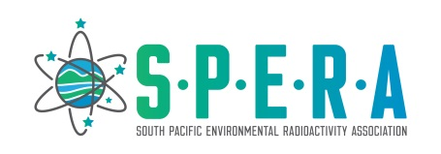

**Scholarship Application Form:**

**Australasian Radiation Protection Society conference (ARPS 2023)**

Dear applicant,

Thank you for your interest in attending the **ARPS 2023 conference.** SPERA will provide two scholarships to cover the full registration fees, one for students and one open to all members. Applications are now open and will be assessed against the following criteria:

1. Scholarships are only available to current financial members.
2. The availability of other sources of workshop/conference assistance you may have.
3. Whether you have received any SPERA travel assistance in the past with preference given to those that have not received previous funding.
4. The relevance and quality of your abstract for a poster presentation.

Regardless of how you address the above criteria, we welcome applications from all members. We particularly encourage young researchers and early career scientists to apply.

Please return this completed application form and abstract (Word doc or PDF) to the SPERA Secretary ([michaela.froehlich@anu.edu.au](mailto:michaela.froehlich@anu.edu.au)) by **Friday 4th August 2023.**

|  |  |  |
| --- | --- | --- |
| Name: | | |
| Email address: | | |
| Institution: | | |
| Other sources of travel assistance you may have e.g. from your institution (give details): | | |
| Have you received SPERA assistance in the past to attend a conference/workshop  (e.g. previous recipient of a travel grant from SPERA)? | Yes | No |
| Please provide a short abstract about the work you intend to present (no more than 200 words): | | |

For student applications:

|  |  |  |  |  |
| --- | --- | --- | --- | --- |
| Course enrolment: | PhD | Masters | Honours | Other: |
| Enrolment status: | Part Time | | Full Time | |